Team 520: Underwater Diver GPS Correction

Operation Manual

**Project Overview**

The intention of the Underwater Diver Global Positioning System (GPS) project is for the device to be used by someone/multiple people SCUBA diving and wanting to mark locations along their dive. It should not be used deeper than 10m or in extreme temperatures. The purpose of this project is to reduce the error in Dr. Rassweiler’s previous tracking device to ensure accurate locations of diseased corals are monitored. This allows Dr. Rassweiler to return to his previous locations to treat sick coral and prevent more coral from falling ill.

**Component/Module Description**

Handheld GPS

The primary component for this project is the GPS. The team is using the Garmin GPSMAP 78 which was given to the team by their sponsor Dr. Rassweiler. The primary feature on this device that the team is using is the Track feature. This gives time-stamped data to include the longitude, latitude, and altitude. A USB-A to Mini B cable is used to read the data from the Track to the user’s computer.

Figure 1: Garmin GPSMAP 78

GPS Module, Microcontroller, and SD Card

The team also decided to implement a GPS module with a microcontroller as an alternative to the Garmin GPS. The specific module used is a BN-880 and is used in conjunction with an Arduino UNO. An SD card is used to record the data from the GPS module allowing the user to export it on their computer after the dive.

Figure 2: GPS Module with Microcontroller and SD Card

Waterproof Housing

The housing for all the electrical components is the Seahorse SE57 Micro Hard Protective Case. The team selected this case as it is small enough to where components cannot easily move around while still being large enough to contain either the Garmin GPS or the GPS module with the microcontroller. Additionally, this case is rustproof and IP67 Waterproof making it a good fit for Dr. Rassweiler’s needs.

Figure 3: Seahorse SE57 Micro Hard Protective Case

Attachable Fins

Attached to the bottom of the housing are two 3D printed fins. The fins increase the stability of the housing while also reducing the chances of the system being pulled underwater as the diver swims around. The fins are based off the FCS II Fins with a mechanism that locks into a mount, securing the fins into place.

Figure 4: 3D Printed FCS II Fins

Attachable Fin Mount

The fins are attached to the housing via a 3D printed mount that is force pressed into the housing. The notch on the bottom right edge of the fin, as seen in Figure 4, allows the fins to securely lock in place without concern of coming off during the dive.

Figure 5: 3D Printed Fin Mount

Line with Attachable Mount

Linking the diver to the surface system is a water-grade line with a reel which allows the diver to reduce the slack in the line prior to the diver recording a point. The reel is attached to the diver via a carabiner and the line is also attached to the housing via a carabiner. A 3D printed mount is attached to the housing via force press and allows the carabiner to attach the line and the housing.

Figure 6: Line with Reel and 3D Printed Mount

Dive Compass

A dive compass is attached to the diver’s buoyancy control device allowing the diver to record the heading throughout the dive. This is used in the post processing of the data to ensure the accuracy of the map that is created from the data.

Figure 7: Dive Compass

Waterproof Paper with Writing Utensil and Clip

Waterproof paper is used throughout the duration of the dive to allow the diver to record the depth, heading, time, and the length of line that is out. The paper is enclosed in a plastic casing with metal fasteners to ensure it does not come out. A mechanical pencil is attached to the casing with rope. A metal clip is also attached to the casing which allows the diver to clip it to their buoyancy control device.

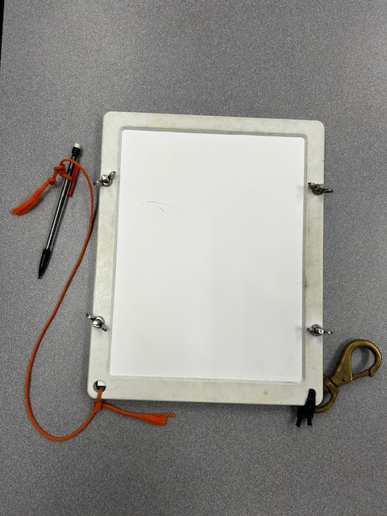

Figure 8: Waterproof Paper with Writing Utensil

Post-Processing App

An application is utilized for post-processing of testing data and the outputting of results. Recorded values taken at underwater points of interest are inputted, calculations are performed to find displacement data, a time value is used to pull an initial reference coordinate of the raft, and a final coordinate set encompassing the initial coordinates summed with the displacement data are displayed. The user is able to simply left click on the outputted coordinates to copy them to their clipboard.

Figure 9: App Home Screen

**Integration**

To assemble the outer components of the Seahorse SE57 Micro Hard Protective Case gather the 3D printed mount, 3D printed fins, two (2) carabiners, and line with reel. First, attach one of the carabiners to the handle of the line and reel as shown in Figure 6 on the left. Second, flip the seahorse case over and force press the 3D printed fin mount and 3D printed mount into the slots shown in Figure 10.

Figure 10: Attached 3D Printed Fin Mount & Carabiner Mount

Lastly for the external assembly attach the last carabiner to the hook in the line and reel then connect both to the 3D printed mount shown in Figure 11.

Figure 11: Attached Carabiner & Line and Reel to the 3D Printed Mount

The internal components of the system can be assembled in three different ways. The first setup contains a GPS module with a microcontroller, the second includes a GPS module with a microcontroller and limit switch, and the third consists of a single GPS device.

GPS Module with Microcontroller

Housed in the Seahorse SE57 Micro Hard Protective Case is the GPS Module (BN-880), SD card reader, portable charger, and Arduino UNO. Diagram 1 demonstrates how these components are assembled. Figure 12 is also shown to see how the box should look after assembly.

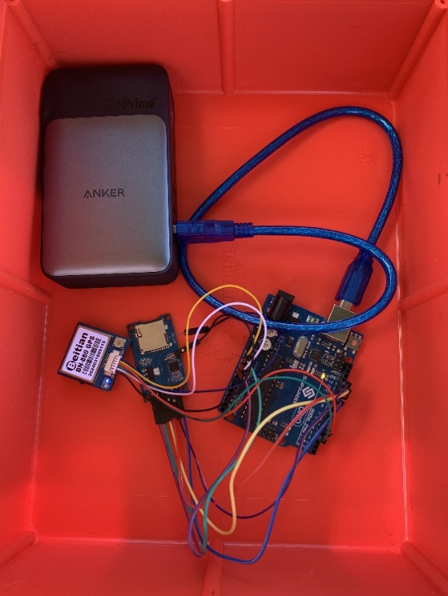

Figure 12: GPS Module with Microcontroller

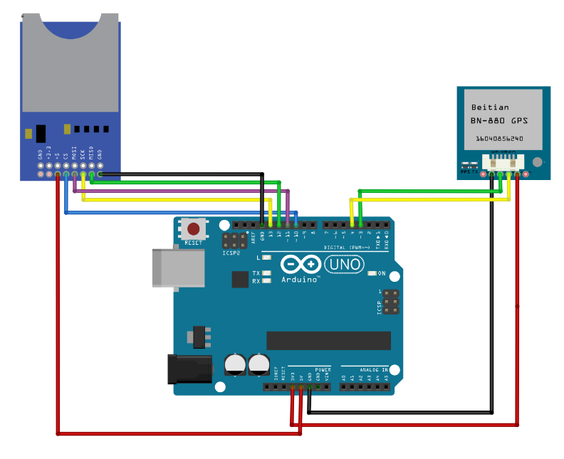

Diagram 1: GPS Module with Microcontroller

GPS Module with Microcontroller & Limit Switch

The setup is identical to the one in the *GPS Module with Microcontroller* section, with an addition of a breadboard and limit switch. Diagram 2 demonstrates how these components are assembled. Figure 13 is also shown to see how the box should look after assembly.

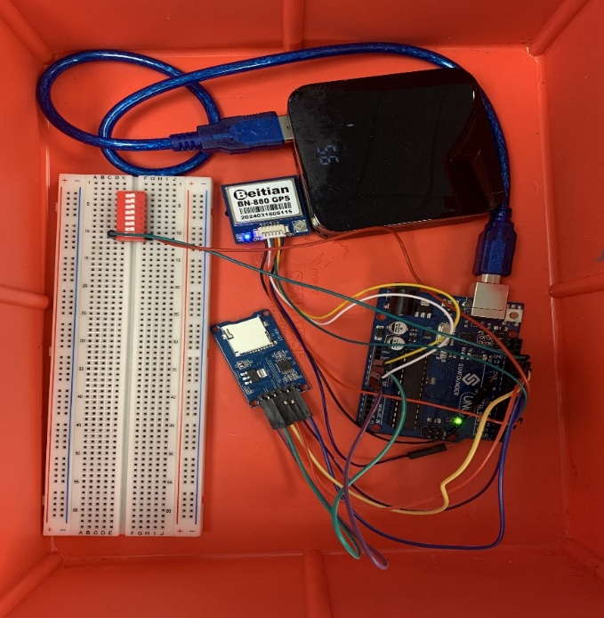

Figure 13: GPS Module with Microcontroller & Limit Switch

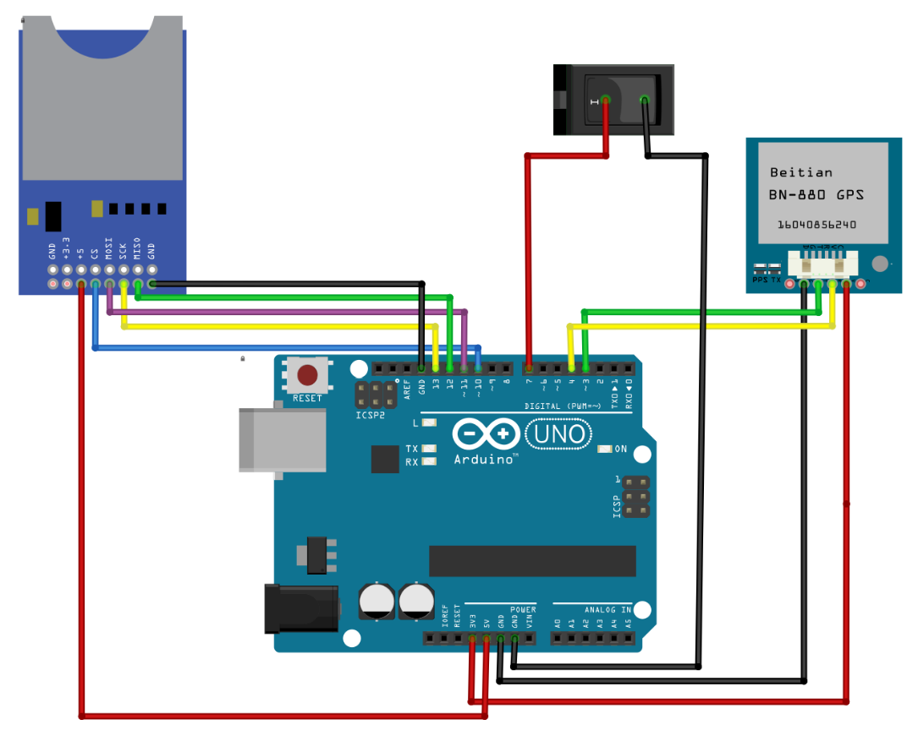

Diagram 2: GPS Module with Microcontroller & Limit Switch

GPS Device

The Garmin GPSMAP 78 is placed inside the Seahorse SE57 Micro Hard Protective Case. Once inside, the user latches the case closed and verifies that it is sealed properly to prevent water from leaking in.

**Operation**

Before the dive, the operator should check that all wires are secured in place and ensure the power source is charged. To assemble the system before each use, the fins will need to be attached to the aft mounting bracket on the bottom of the box. These can be inserted with the notch locking into the mount. The end of the measuring reel also needs to be clipped onto the front loop mount if it is not already. The body of the reel should be clipped onto the diver along with the underwater writing board. The diver should also be wearing/have access to the underwater compass before going in the water. When the diver is ready to dive and right before they get in the water, they will need to choose if they want to use the GPS module and Arduino or the handheld GPS device.

If they are using the GPS module: Plug the power cord into the portable charger. The GPS module should light up with a little blue light. The diver needs to wait for it to receive a signal which can take a few seconds or up to 15 minutes. Once the signal is received, a light next to the blue one will blink red. Once the red light is on, the SD card can be inserted. Once the diver is ready for their time to start, they can press the small button in the corner of the Arduino.

If they are using the handheld GPS device: Turn on the GPS. Press the menu button twice. Use the arrows to navigate to “Track Manager” and press enter. Press enter on “Current Track”. Press enter on “Save Track”. Name the file accordingly (that will be the GPS data from when the last file was saved until now). Navigate to “Done” and press enter. Press enter on “Yes”. After that, it takes you back to the different track screens and the new track has already started.

The diver should make sure the components are in their proper places within the foam inserts before closing the box and securing the latches. Bring the box into the water and place it on the surface. Make sure the measuring tape is not wrapped around the fins before starting. The diver can start their dive as normal and just be mindful of not allowing too much measuring line slack to accumulate so it does not get caught on anything. Once the diver reaches a point they want to log, they should reel in the measuring line as tight as possible without pulling the box underwater. Lock the reel in place by flipping the lever. Record on the underwater writing pad the time, the length shown on the measuring line, and the depth shown on the dive watch. Use the underwater compass to judge the heading of the line compared to the diver’s location. Record this value along with the other points as a degree from 1-360. Also record the significance of that spot if that is relevant. Then, the diver can release the tension in the reel and continue the dive until they find another point of interest.

Once the dive is complete, towel down the box a bit and use dry hands to open the box. If using the handheld GPS, use the same instructions as listed above to end the track. If using the GPS module, activate the switch to end the track and then the SD card can be removed.

To analyze the data, import the data onto a laptop. If the diver used the handheld GPS, this can be done by plugging the GPS into the computer using the mini-B to USB-A cord. Open the Garmin dnrgps software to display the data from the GPS. The data can then be uploaded to a folder on the computer like a flash drive. If using the GPS module, the SD card can be inserted into an SD or micro-SD reader and then the files can be uploaded onto the computer. After the files are on the computer, use the GPS Diver app and import the .gpx file into it. Before using the app, make sure the time zone feature is set to the correct time zone. Also, the reference latitude is automatically set for Bonaire, if the diver is getting data from elsewhere, they will have to change their reference latitude each time they access the site. After the data is imported, each point can be logged by putting in the written information from the dive. The app will output the coordinates of where the diver was and plot the point(s) onto a map.

**Troubleshooting**

If the system attachments, fins, or mounts fail the user can 3D print off new attachments using the SolidWorks Standard Triangle Language (STL) files given when the system is acquired.

Preliminary troubleshooting for the application always should be a simple refresh of the webpage. If invalid data is inputted, the user should receive an error message detailing what is being entered incorrectly. If the file fails to upload properly, which should be indicated by the button turning from blue to green, double-check that the file is in the .GPX format. If the coordinates return unexpected values, be sure to check the following:

* The distance measurements for depth, length of line should be inputted in meters
* The time zone drop-down, located at the top right-hand corner of the application, should reflect the time data is being recorded on the GPS device
* The reference latitude is pre-set for Bonaire, if the user is testing in a different location the reference latitude should be adjusted accordingly